Dilate an Image using Dilate Function
Code
import cv2
import numpy as np
from google.colab.patches import cv2_imshow
from google.colab import files
uploaded=files.upload()
image_path=list(uploaded.keys())[0]
image=cv2.imread(image_path,cv2.IMREAD_GRAYSCALE)
if image is None:
print("Error: Image not found")
else:
kernel=np.ones((5,5),np.uint8)
dilated_image=cv2.dilate(image,kernel,iterations=1)
print("Original Image")
cv2_imshow(image)
print("Dilated Image")
cv2_imshow(dilated_image)
Input Image
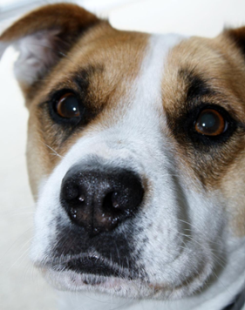
Output Image
Dilated Image
